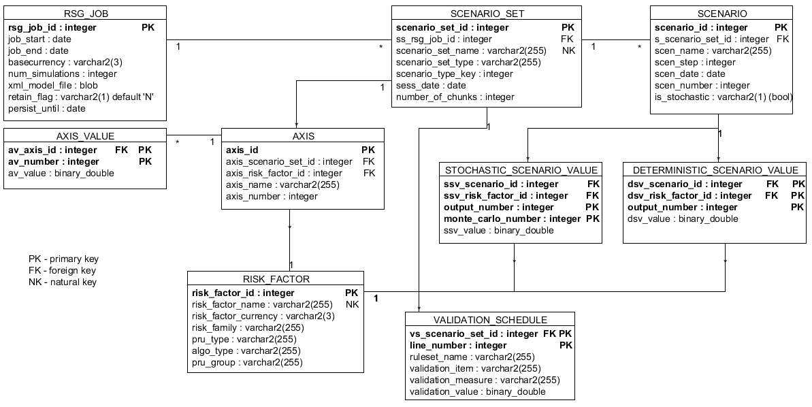

RSG_JOB – represents the execution of one RSG use case by RSG. Field NUM_SIMULATIONS – the number of monte carlo simulations. Field XML_MODEL_FILE is a BLOB with the serialised XML use case model file.

RISK_FACTOR – table of all risk factors.

SCENARIO_SET – each RSG_JOB can have one or more SCENARIO_SETS. Each SCENARIO_SET consists of one or more deterministic scenarios and one stochastic scenario.

SCENARIO – table for scenario-set scenarios. If the scenario is stochastic – SCENARIO.IS_STOCHASTIC == ‘Y’. For deterministic scenarios SCENARIO.IS_STOCHASTIC == ‘N’.

STOCHASTIC_SCENARIO_VALUE – holds the monte carlo samples of a stochastic scenario. SSV_SCENARIO_ID – id of the stochastic scenario. SSV_RISK_FACTOR_ID – the id of the risk factor. OUTPUT_NUMBER – the stochastic output number of the risk factor(for example the yield curves have 90 points, so this field has values from 1 to 90). MONTE_CARLO_NUMBER – the number of the monte carlo simulation that has produced the sample stored in field SSV_VALUE. The outputs are serialised according to the ALGO binary file convention.

DETERMINISTIC_SCENARIO_VALUE – the values of a deterministic scenario. DSV_SCENARIO_ID – id of the deterministic scenario. DSV_RISK_FACTOR_ID – the id of the risk factor. OUTPUT_NUMBER – the output number of the risk factor(for example the yield curves have 90 points, so this field has values from 1 to 90). DSV_VALUE holds the deterministic value of the i-th output of the risk factor.

AXIS and AXIS_VALUE – describe the dimensionality of each RISK_FACTOR outputs in a particular SCENARIO_SET. AXIS.AXIS_NAME is the name of the axis – ex. ‘Term’, AXIS.AXIS_NUMBER is the dimensional order of this axis. AXIS_VALUE.AV_VALUE holds the values of particular axis – ex. 1, 2 …90 [years].